Mongo DB Assignment-1

Q1. Create a new database called student_management.



Q2. Create a collection called students in the student_management database.



Q3. Insert at least five student records into the students collection. Each record should have the following fields:

* student_id (integer)
* name (string)
* age (integer)
* department (string)
* courses (array of strings)
* grade (string)

db.student.insertMany([

{student_id:101,name:"Frankline",age:20,department:"Computer Science",course:["HTML","DataBase system"],grade:"A"},

{student_id:102,name:"Lester",age:21,department:"Computer Science",course:["HTML","DataBase system"],grade:"B"},

{student_id:103,name:"Trevor",age:23,department:"Information Technology",course:["B.Tech","B.Com"],grade:"C"},

{student_id:104,name:"Micheal",age:20,department:"Hotel Management",course:["BHM","BBA"],grade:"D"},

{student_id:105,name:"Jhon",age:25,department:"Information Technology",course:["B.Tech","B.Com"],grade:"A"},

{student_id:106,name:"Top",age:24,department:"Hotel Management",course:["BHM","BBA"],grade:"B"}])

Q4. Query the Collection:

Write queries to perform the following tasks:

*Retrieve all students who are in the "Computer Science" department.

db.student.find({department:"Computer Science"})

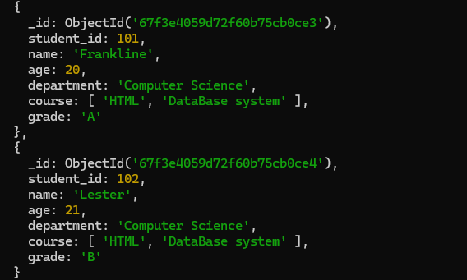*534

*Retrieve students who have an age greater than 21

db.student.find({age:{$gt:21}})

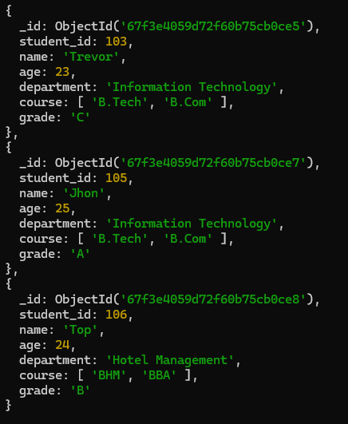

*Retrieve students who are taking the "Database Systems" course

db.student.find({course:"DataBase system"})

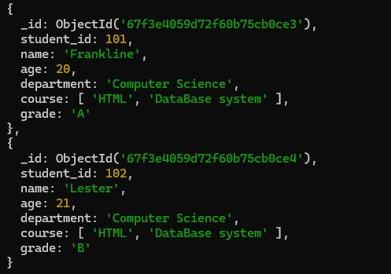

*Retrieve students with a grade of "A".

db.student.find({grade:"A"})

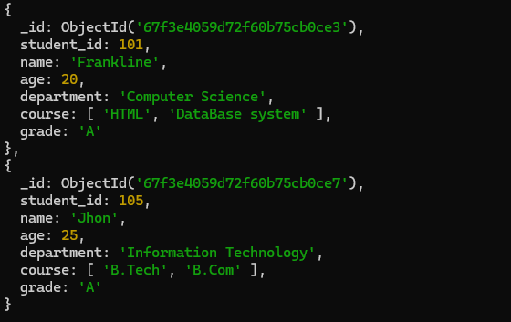

Q5. Update Documents:

*Update the age of a student with student_id 101 to 21

db.student.updateOne({student_id:101},{$set:{age:21}})

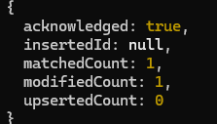

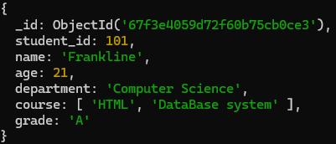

*Add a new course, "Machine Learning", to the courses array for students in the "Computer Science" department.

db.student.updateMany({department:"Computer Science"},{$addToSet:{course:"Machine Learning"}})

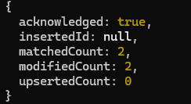

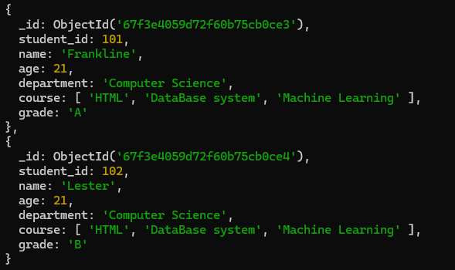

Q6. Delete Documents:

Delete a student record with student_id 105

db.student.deleteOne({student_id:105})



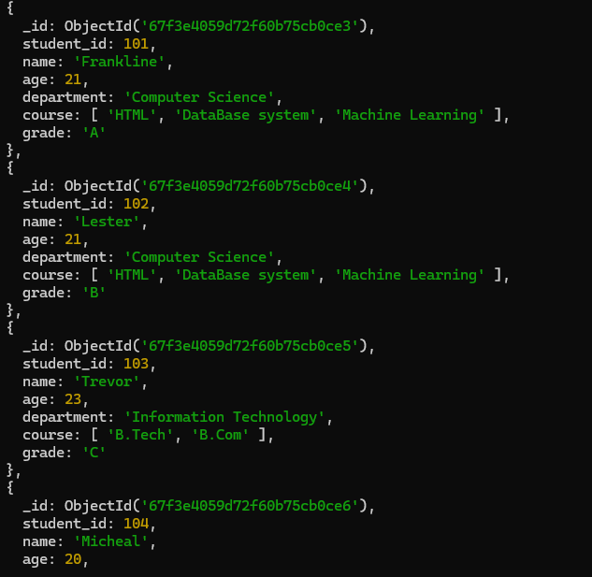

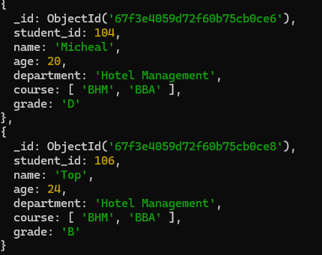

*Delete all students who have a grade lower than "C".

db.student.deleteMany({grade:{$lt:"C"}})

